

**MASENO UNIVERSITY**

**SCHOOL OF COMPUTING AND INFORMATICS**

**DEPARTMENT OF COMPUTER SCIENCE**

**CCS 403: FINAL YEAR PROJECT**

**TITLE:** FOOTBALL EVENT AND INFORMATICS MANAGEMENT PLATFORM

**REG.NO:** CI/00015/015

**NAME:** EMMANUEL A. AMANGA

A project report submitted in partial fulfillment of the requirements for the

Bachelor of Science degree (BSc.) in Computer Science

**(DECEMBER 2018)**

# DECLARATION

I, Emmanuel Andoyi Amanga do hereby declare that this project proposal is my original work and to the best of my knowledge that this project has not been presented to any other examination body.

Emmanuel Andoyi Amanga Signed: .......................... Date: ....../.........../......

# APPROVAL

This Project proposal is submitted for approval to the following supervisor.

Signed: ........................................ Date: ...............................

Mr. Kevin Mugoye

Coordinator & Lecturer

Department of computing sciences

Faculty of Computing and Informatics

# ABSTRACT

Overtime, football has captured the interests of many investors as well as players and the participants. Many organizations are putting in much effort to ensure that clarity and formalities are upheld. Despite the fact that there are other sport activities, football has captured my attention due to the rising need for automation of its activities.

The existing system does not provide for locally arranged football matches and that makes football event and information management platform to have an upper hand. Several systems have been developed on the basis of football results prediction. These systems depend majorly on already generated fixtures as well as relayed from other sites.

The main objective of this system is to develop a web based application that will automate tournament game fixtures. Besides provide for players, coaches, sponsors, spectators, fans, and other users to view match fixtures of ongoing tournaments, the team manager can organize the teams, a report can be auto generated and be sent to the respective sponsors and coaches are specific objectives to be achieved as well.

The technologies that will facilitate achieving the main objective include: MYSQL an open-source relational database management system as the data store, PHP programming language that provides for Laravel framework for front and as well as back end, JavaScript for interactive web pages, Hypertext Markup Language for the WebPages frames or backbone, Cascading Style Sheets for design of user interfaces. Other technologies such as python or SQLite will also be implemented to solve certain specific modules or cater for any arising need of their concern.

The success of this system is remedy to football local tournament arrangement complexity. This will enable partisans to be exposed to free and fair fixture without favor of any of the teams perpetuated by human conscience. The system should be able to stipulate high levels of integrity and openness.

# DEDICATION

I dedicate this project to God Almighty my creator, my strong pillar, my source of inspiration, wisdom, knowledge and understanding. He has been the source of my strength throughout this program.

# ACKNOWLEDGEMENT

I thank the Almighty God for giving me the will, strength, patience and good health.

My sincere appreciation and thanks to my supervisor, Mr. Kevin for his guidance, Support throughout this research proposal. May the Lord bless him?

To all my friends who shared knowledge with me during the entire process, I give them my regards. Finally, I would like to appreciate anyone who by either direct or indirect means contributed to the success of my project.

Table of Contents

DECLARATION i

APPROVAL i

ABSTRACT ii

DEDICATION iii

ACKNOWLEDGEMENT iv

LIST OF FIGURES vii

LIST OF TABLES viii

LIST OF ABBREVIATIONS AND ACRONYMS ix

CHAPTER ONE: INTRODUCTION 1

1.0 Background of the study 1

1.1 Problem statement 2

1.2 Objectives of the study 3

1.2.1 Main Objective 3

1.2.2 Specific objective 3

1.3 Significance of the study 3

1.4 Scope of the study 3

CHAPTER TWO: LITERATURE REVIEW 4

2.0 Introduction 4

2.1 Review of Literature 4

2.2 Technology and Football 5

2.3 Other Related Applications 6

2.3.0 Jersey Watch 6

2.3.1 LeagueApps 6

2.3.2 SportsEngine 6

2.3.3 Payscape 7

2.3.4 Engage Sports’ 7

2.4 Drawbacks of available systems 7

2.5 Benefits of FEIMS over other Applications 7

CHAPTER THREE: METHODOLOGY 8

3.0 Introduction 8

3.2 Feasibility Study 8

3.2.0 Technical Feasibility 8

3.2.1 Social and operational feasibility 8

3.2.2 Economic feasibility 9

3.2.3 Operational Feasibility 9

3.2.4 Schedule feasibility 9

3.3 System Analysis and Design. 9

3.3.1 Waterfall Model 9

3.3.2 Reasons for Using This Methodology 12

3.3.3 Shortcomings of This Methodology 12

3.4 Functional specification 12

3.4.1 Functional Requirement 12

3.4.2 Non-Functional Requirements. 13

3.5 Hardware Requirements 13

3.6 Software requirement 14

3.6 System Design 14

3.6.1 Design Goals 14

3.6.2 Architecture of the System 14

3.6.3 Database Design 16

3.6.3.1 Need for Database Design 16

3.6.3.2 Database Tables Proposed 16

3.7 Analysis Model 17

3.7.1 Use case Diagram 18

3.7.2 Class Diagram 25

3.7.3 Sequence Diagram 27

3.8 Summary 29

# LIST OF FIGURES

Figure 1 summary of system development life cycle - waterfall model. 10

Figure 2 Architecture of the system 15

Figure 3 use case diagram of the FEIMS 17

Figure 4 Class Diagram 25

Figure 5 Sequence Diagram for a Login Senario 27

# LIST OF TABLES

# LIST OF ABBREVIATIONS AND ACRONYMS

|  |  |
| --- | --- |
| ABRIVIATION OR ACRONYM | DESCRIPTION |
| **Apps** | Software programs that have been developed to run on a computer or mobile device to accomplish a specific purpose. |
| **FEIMS** | Football Event and Information Management System. |
| **URL** | Uniform Resource Locator |
| **MySQL** | Structured Query Language |
| **XML** | extensible Markup Language |
| **PHP** | Hypertext Preprocessor |
| **HTML** | Hypertext Markup Language |
| **DB** | Database |
| **WEB** | Website |
| LEAGUE | An organization of sports teams which play against one another for championship. |

# CHAPTER ONE: INTRODUCTION

## Background of the study

Football is a very popular sport all over the world. Most of the countries have invested a lot in football sport. Together with the events that come handy with this sport, these events need to be captured, tracked, analyzed and stored for future reference as well as history for the teams and performances. Thus FEIMS is an up to task system that would take care of these requirements.

This FEIMS is a web and mobile based application that facilitates and or automates the football activities including but not limited to registering players, registering teams, with their relevant stakeholders(coach, sponsors), arranging tournaments both long and short term tournaments. Organizing and facilitating contracts, advising on the best teams that match to play head to head.

The systems main aim is to automate the process of organizing football events. This is to reduce conflicts that usually arise due to human misunderstanding on which teams should play against the other. In Kenya as an example many football events are organized using the manual system through which a group of people come together there by selecting the teams that will play against the other. This way of selection may end up favoring certain teams giving them an easy way through the league or tournament. Besides one may decide to corrupt other members into voting his/her team in favor of the other teams.

The development of this system will be based on responsiveness to facilitate its access from mobile or tablet computers (gadgets). Both server and client languages will be used during development to ensure a full real-time functioning system. The system will also be composed of the font-end (client/user) side for user access, and the administrative side for administrative purpose.

In conclusion, the system should also be able to send notifications to the users who register as well as those who are willing to get notifications on upcoming events. The admin should also be able to generate analysis of the events, generate reports for each team performance at the end of each tournament.

## 1.1 Problem statement

A football game is composed of two teams playing against each other for at least ninety minutes. The winner is determined by the team that scores more number of goals than the other otherwise the teams draw. This may lead to an additional time of about thirty minutes, if still no winner then there would be penalties. This goes on till a winner is determined.

Tournaments are events that take place over a short period, often just a single day, weekend or week. They involve a relatively large number of teams or players playing lots of matches at the same venue. Often the competition features an abbreviated form of the sport (definition [www.sportengland.org/runningsport](http://www.sportengland.org/runningsport)).

Tournaments can be organized on a knock-out basis, but, if they involve shortened versions of the game, many will have been knocked out before they have had the opportunity to play a match of reasonable length. A mini-league, pool or ‘group’ system ensures that all participants play more than one match, after which those at the top of their pool go through to a later knockout stage, and this is usually more satisfactory. Another successful system is to run a consolation event (often called a ‘plate’ competition) for those who lose in the group stages.

The problem arises when these teams need to be selected for their very first groups. In those groups how the teams need to play against each other is yet another problem. All this and many proceeding game problems are what are to be handled by this system.

The existing system takes to account these functionalities but in a more manual way an administrator has to physically assign a pools or groups with their respective teams. This is somehow cumbersome for the case that involves just more than five pools or groups.

This system in tern should solve this problem by automating this functionality as the main objective. Among other objectives this will greatly help reduce the bulkiness of handling junks of communications done during preparation of the events. All communications will be centralized and easy to reach all or those intended just through the system.

Through addressing of the above problems, there shall be great improvement in the speed, reliability, efficiency and accuracy of the entire process of tournament preparation.

## 1.2 Objectives of the study

### 1.2.1 Main Objective

The main objective of this system is to automate football tournament events.

### 1.2.2 Specific objective

The specific objectives of this system are:

* To store and manage teams, players, tournaments information.
* To track team, player, coaches, progress/performance.
* To ensure the best match for teams playing against each other.
* To safeguard information through authorized access via log in or registration.
* To provide for a convenient method of payment for tournaments/games registration fee.

## 1.3 Significance of the study

Football has with time continued to receive so much attention from many investors all over the world. This intern serves as evidence that football has come in to be a source of income to most of the youth as well as a source of entertainment to the fans/spectators. The revenue of some of the countries is enhanced through taxation. Football also has lead to creation of other opportunities such as football prediction sites, football analysis and prediction experts and much more. FEIMS comes in to ensure that this and any other involved parties are well coordinated and are working efficiently and as required. The implementation of this system will see into it that time is saved as well as the cost of coordinating the events is by far cut. Since it is a web-based application it is not limited to a specific relocation and therefore global accessibility widens the scope to cover most or all accessible areas.

## 1.4 Scope of the study

FEIMS shall be developed to be accessed through the web. One should be able to access it through any of the devices since it shall be developed to be a responsive web application. This application should support major football tournament event requirements including team registration, tournament registration, venue of the tournament, time of the tournament, awards as well as fixtures and team progress.

# CHAPTER TWO: LITERATURE REVIEW

## 2.0 Introduction

Football is a game played by two teams of [eleven](https://www.collinsdictionary.com/dictionary/english/eleven) [players](https://www.collinsdictionary.com/dictionary/english/player) using a round ball. Players kick the ball to each other and [try](https://www.collinsdictionary.com/dictionary/english/try) to [score](https://www.collinsdictionary.com/dictionary/english/score) goals by [kicking](https://www.collinsdictionary.com/dictionary/english/kicking) the ball into a large [net](https://www.collinsdictionary.com/dictionary/english/net) (Collins dictionary).

A game in which two opposing teams of11 players each defend goals at opposite ends of a field havinggoal posts at each end, with points being scored chiefly by carrying the ball across the opponent's goalline and by placekicking or dropkicking the ball over the crossbar between the opponent's goal posts([www.dictionary.com](http://www.dictionary.com)).

## 2.1 Review of Literature

According to fifa.com, the contemporary history of the world's favorite game spans more than 100 years. It all began in 1863 in England, when rugby football and association football branched off on their different courses and the Football Association in England was formed - becoming the sport's first governing body.

Both codes stemmed from a common root and both have a long and intricately branched ancestral tree. A search down the centuries reveals at least half a dozen different games, varying to different degrees, and to which the historical development of football has been traced back. Whether this can be justified in some instances is disputable. Nevertheless, the fact remains that people have enjoyed kicking a ball about for thousands of years and there is absolutely no reason to consider it an aberration of the more 'natural' form of playing a ball with the hands.

On the contrary, apart from the need to employ the legs and feet in tough tussles for the ball, often without any laws for protection, it was recognized right at the outset that the art of controlling the ball with the feet was not easy and, as such, required no small measure of skill. The very earliest form of the game for which there is scientific evidence was an exercise from a military manual dating back to the second and third centuries BC in China.

This Han Dynasty forebear of football was called Tsu' Chu and it consisted of kicking a leather ball filled with feathers and hair through an opening, measuring only 30-40cm in width, into a small net fixed onto long bamboo canes. According to one variation of this exercise, the player was not permitted to aim at his target unimpeded, but had to use his feet, chest, back and shoulders while trying to withstand the attacks of his opponents. Use of the hands was not permitted.   
Another form of the game, also originating from the Far East, was the Japanese Kemari, which began some 500-600 years later and is still played today. This is a sport lacking the competitive element of Tsu' Chu with no struggle for possession involved. Standing in a circle, the players had to pass the ball to each other, in a relatively small space, trying not to let it touch the ground.

The Greek 'Episkyros' - of which few concrete details survive - was much livelier, as was the Roman 'Harpastum'. The latter was played out with a smaller ball by two teams on a rectangular field marked by boundary lines and a centre line. The objective was to get the ball over the opposition's boundary lines and as players passed it between themselves, trickery was the order of the day. The game remained popular for 700-800 years, but, although the Romans took it to Britain with them, the use of feet was so small as to scarcely be of consequence.

## 2.2 Technology and Football

Over time there has been increased use of technology in football activities. The latest of them is the use of Goal Line Technology. This technology is used to determine whether or not a team has scored. This technology works on the theory that since the ball must be 60 millisecond behind the goal line to be seen by human eye, the technology solves this by sending a signal to the game managers as well as the referee within a millisecond. This can be achieved through use of camera or use of magnetic fields.

From the rising interest in organizing and preparing events, much software has been developed to curb the hectic activities, operations and processes involved. Inculcating technology in football event preparation solves;

**Reduced Costs**

With web technology the universal accessibility of resources has greatly reduced or cut costs. FEIMS system cuts on costs such that

**Saves Time**

Time taken by the football management to travel all the way to the venue of the game or tournament to so a follow up on a game or do registration of a team is saved since the system is accessible from any place at any time.

**Reduce Paper Work**

This automation will greatly reduce paper work since many transactions will be processed and accountability will be delivered through emails or text messages.

**Feedback System**

Once a game or a tournament has ended one can reach out to the participants or the players to get to know how the tournament was. Also one should be able to reach out to the team managers to get to know on the best place to hold the tournament or their views about the fixtures.

## 2.3 Other Related Applications

### 2.3.0 Jersey Watch

Jersey Watch is a cloud-based sports league management solution for leagues, clubs and teams. Key features include player registration, payment collection, website management and SMS communication.

### 2.3.1 LeagueApps

LeagueApps is a cloud-based sports league management solution for soccer, basketball, softball, volleyball, flag football, and kickball and hockey league events. The product offers online registration, schedules, member communication, website management and reporting functionalities within a suite.

### 2.3.2 [SportsEngine](https://www.capterra.com/external_click_sa/category-upgraded-product/3/2094417/134125/sportsleag/aHR0cDovL3d3dy5zcG9ydHNlbmdpbmUuY29tL2ZyZWUtcXVvdGUvP2xlYWRfc291cmNlPWNhcHRlcnJhJnV0bV9jYW1wYWlnbj1jYXB0ZXJyYSZ1dG1fc291cmNlPWNhcHRlcnJhJnV0bV9tZWRpdW09cHBj?ga_client_id=2099892752.1540874012)

SportsEngine is a cloud-based sports management solution for sports-event organizers. The software helps users manage operations, online registration, leagues organization and website design.

### 2.3.3 Payscape

Payscape is a cloud-based event registration solution designed for all kinds of sporting events. It offers online registration, scheduling, team assignments and automatic payment tools within a suite.

### 2.3.4 Engage Sports’

Engage Sports’ website feature enables users to create personalized mobile-compatible sites, which consist of a content management system (CMS), social media integration, blogs, discussion forums and photo gallery.

## 2.4 Drawbacks of available systems

The review described has the following problems:

* Most of them are platform independent.
* Most systems are not financially feasible.
* Most systems are configured to perform many other operations thus the objectives might not be met.
* Complex to use
* Most systems are not responsive in case of smaller devices.

## 2.5 Benefits of FEIMS over other Applications

The benefits of this application as compared to the above mentioned applications are:

* Simple to understand and operate.
* Automation of schedules or fixtures to avoid inconveniences as favors.
* Responsive designs for mobile or small screen devices.
* Central point for all teams in the tournament.
* Generation of reports and statistics of every event.

# CHAPTER THREE: METHODOLOGY

## 3.0 Introduction

Methodology is a systematic, theoretical analysis of the methods applied to a field of study. It comprises of theoretical analysis of the body of method of principles associated with a branch of knowledge. Typically, it encompasses concepts such as paradigm, theoretical model, phases and quantitative or qualitative techniques.

**3.1 Data Collection Methods**

Primary Data collection:

* Data will be collected through Interviews using structured and unstructured questionnaires. Questionnaires were designed and given to the intended interviewees. They gave their response according to the questions.
* Interviews.

This will be a one on one conversation between the interviewer and the interviewee. Questions were asked orally and the respondents gave their feedback.

Secondary data collection:

* Information from the internet.

This included various sites under the same title.

## 3.2 Feasibility Study

### 3.2.0 Technical Feasibility

* Are the current equipment and the existing technology capable of fulfilling the requirements of the new system? Since the system is online I will be required to set up the facility of computer including a server. Some necessary hardware and software are needed for this system. Technical staff is needed for responsibility of taking care of the server and database.

### 3.2.1 Social and operational feasibility

* The system is operational feasible because it can be used effectively after it has been implemented. The problem can be solved by introducing the new system, this will boost the operations.

### 3.2.2 Economic feasibility

* Economic justification includes a broad range of concerns that includes cost benefit analysis. The resources (hardware and software) needed to create the system, since they were readily available they cost us less and thus the economic feasibility. The maintenance and scaling of the system is not also expensive. It’s easy and fast to modify and carry out the changes that one may require to change.

### 3.2.3 Operational Feasibility

* It mainly involves with how much ease the users can use the system. It shall have a well laid out features and menus in the front end selection section such that all users that need to access the system can easily use the system with ease and with minimal errors.

### 3.2.4 Schedule feasibility

* Time evaluation is the most important consideration in the development of project. The time schedule required for the developed of this project is very important since more development time effect machine time, cost and cause delay in the development of other systems. This majorly is the amount of time required to begin and complete a given project on time. Also, the amount of time that the given system should be in operation before it can bring up any maintenance issue is also a factor to consider. The time span is the main factor here.

## 3.3 System Analysis and Design.

The prioritized requirements will now be used to make critical design decisions of the web-based FEIMS. The design is intended to be highly compatible and usable on most platforms hence accessible to the larger part of the public.

### 3.3.1 Waterfall Model

The waterfall model illustrates the software development process in a linear sequential flow; hence it is also referred to as linear sequential life cycle model. This means that any phase in the development process begins only if the previous phase is complete. In waterfall model phases do not overlap.

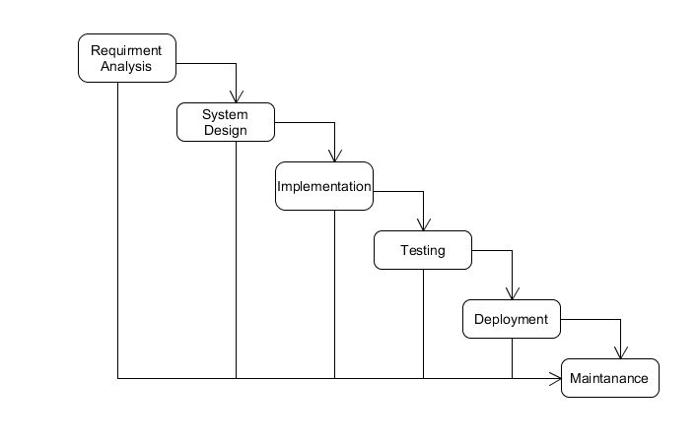

Figure 1 summary of system development life cycle - waterfall model.

Step by step description.

**Requirements gathering**:

All possible requirements of the system to be developed are captured at this stage and documented in a requirement specification document.

Requirements are gathered through:

* Studying the existing or the obsolete system software.
* Conducting interviews of users and developers,
* Referring to the database,
* Collecting answers from questionnaires.

**System design**:

The requirements specifications from the first phase are studied in this stage and system design is prepared. System design helps in specifying hardware and system requirements and also helps in defining overall system architecture.

**Implementation**:

With inputs from system design, the system is first developed in small programs called units or modules which are integrated into the next phase. Each unit is developed and tested for its functionality which is referred to as unit testing.

**Integration and testing**:

All the units developed in the implementation phase are integrated into a system after testing of each unit. Post integration the entire system is tested for any faults and failures.

**Development of system**:

Once the functional and non-functional testing is done, the product is deployed in the customer environment or released into the market.

**Maintenance**:

There are some issues which come up in the client environment. To fix those issues patches are released. Also to enhance the product some better versions are released. Maintenance is done to deliver these changes in the customer environment.

**Deployment of system**:

Once the functional and non-functional testing is done, the product is deployed in the customer environment or released into the market.

**Maintenance**:

There are some issues which come up in the client environment. To fix those issues patches are released. Also to enhance the product some better versions are released. Maintenance is done to deliver these changes in the customer environment.

### 

### 3.3.2 Reasons for Using This Methodology

* Easy to explain to the users.
* Structures approach.
* Stages and activities are well defined.
* Helps to plan and schedule the project.
* Verification at each stage ensures early detection of errors/misunderstanding.
* Each phase has specific deliverables.
* Clear project objectives
* Stable project requirement.
* Progress of system is measurable.
* Strict sign-off requirement.

### 3.3.3 Shortcomings of This Methodology

* Assumes that the requirements of a system can be frozen.
* Very difficult to go back to any stage after it finished.
* A little flexibility and adjusting scope is difficult and expensive.
* Costly and required more time, in addition to the detailed plan.
* Time consuming.
* Never backward (traditional)
* Little room for iteration.
* Difficulty responding to changes.

## 3.4 Functional specification

### 3.4.1 Functional Requirement

The functional requirements of the system are:

* + Register a player, team/club, tournament
  + Book a ticket for the game or tournament,
  + Generate various reports,
* Manage records
* Should be able to send emails to the respective recipients.

### 3.4.2 Non-Functional Requirements.

1. **Usability**

* The system is easy to learn and to use. In this way it eliminates the need for travel and a lot of training which is both expensive and time consuming

1. **Reliability**

* the system is stable and not prone to errors

1. **Maintainability**

* The system can be retained in its original form, and can also be easily restored to this form in case of a failure.

1. **Fast**

* The system is fast in terms of access but also relies heavily on internet speed.

1. **Scalable**

* The system can accommodate an increasing number of users without changing functionality.

1. **Security*:***

* The system must be secure, allowing only authorized users to access other users’ information.

## 3.5 Hardware Requirements

My proposed system offers excellent flexibility in terms of hardware and the following hardware configuration and the following user cases will be adequately covered:

1. People operating on android phones will be able to access the service using any type of internet connection as well as any type of browser.

2. The users can be equipped with internet signal transceivers, a webserver and a wireless router enabling more portable and mostly cheaper devices such as smartphones and tablet computers to be used.

Tools required:

1. computer
2. A text editor e.g. brackets, sublime, Notepad++, Adobe Dreamweaver
3. Internet Browser e.g. Mozilla Firefox, Chrome, Internet explorer.
4. Apache server. E.g. XAMPP, WAMP, IIS.

## 3.6 Software requirement

With portability and flexibility in mind, the system is online and run by the client side browser and optimized for the various contemporary devices used today. This offers any enterprise flexibility and fault tolerance in case one avenue of service provision fails.

The adoption of WAMP platforms which is open source and free not only cuts down costs but also offers the company the flexibility to add features in accordance to needs and requirements as they arise.

## 3.6 System Design

### 3.6.1 Design Goals

Design goals describe the qualities of the system that developers should optimize. Such goals are normally derived from the non-functional requirements of the system.

Design goals are grouped into five categories. These are:

* + Performance
  + Dependability
  + Maintenance
  + End User Criteria

### 3.6.2 Architecture of the System

The proposed system is expected to replace the existing manual system by an automated system in all facets.

The architecture used for the system is a 3 tier Client/Server Architecture where a client can use Internet browsers to access the online report provided by the system within the local area network of the school or anywhere using the Internet. Figure 2 shows the architecture of the proposed system.

A web server is a program that runs on a network server (computer) to respond to HTTP requests. The most commonly used web servers are Internet Information Server (IIS) and Apache. The web server used in this system is IIS. HTTP is used to transfer data across an Intranet or the Internet. It is the standard protocol for moving data across the internet.

The client tier is the applications user interface containing data entry forms and client-side applications. It displays data to the user. Users interact directly with the application through user interface. The client tier interacts with the web/application server to make requests and to retrieve data from the database. It then displays to the user the data retrieved from the server.

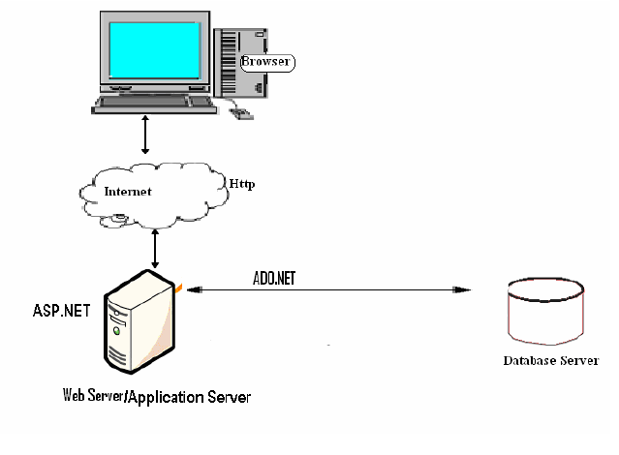

Figure 2 Architecture of the system

### 3.6.3 Database Design

#### 3.6.3.1 Need for Database Design

The system utilizes the use of **database**, a database is an organized collection of data, generally stored and accessed electronically from a computer system. It is used to store data and information, which is, interested in the business for example the Product information, Client information and service information.

Database is a store for information. In the proposed system, I will use a database to store all the information required by the system either for future or temporarily for use as required.

#### 3.6.3.2 Database Tables Proposed

The proposed system will use MySQL. MySQL is an open source Database Management System (DBMS) developed by MySQL AB, (<http://www.mysql.com>).

MSQL is one of the top databases available in the ICT world. MYSQL is a Relational Database Management System (RDBMS) (a database structured to recognize relations between stored items of information) with many advanced features and options. The following, are the proposed tables to be created in the database:

|  |  |
| --- | --- |
| USER TABLE | |
| FIELD | TYPE |
| Name | Varchar(191) |
| dob | Date |
| Email | Varchar(191) |
| phone | Integer |
| Best_team | Integer |
| Best_player | Integer |

Table 1 Users Table

## 3.7 Analysis Model

To produce a model of the system which is correct, complete and consistent I need to construct the analysis model which focuses on structuring and formalizing the requirements of the system. Analysis model contains three models: functional, object and dynamic models.

The functional model can be described by **use case diagrams**. Use case diagrams are usually referred to as **behavior** **diagrams** used to describe a set of actions (**use cases**) that some system or systems (subject) should or can perform in collaboration with one or more external users of the system (actors).

An object model is a logical interface, software or system that is modeled through the use of object-oriented techniques. It enables the creation of an architectural software or system model prior to development or programming. An object model is part of the object-oriented programming (OOP) lifecycle (<https://www.techopedia.com/definition/8635/object-model>). **Class Diagram** is the best tool to use to represent object model. It stipulates structure of a particular system by modeling its **classes**, attributes, operations, and relationships between objects.

The dynamic model is used to express and model the behavior of the system over time. It includes support for activity diagrams, state diagrams, sequence diagrams and extensions. In this proposal I opt to use **Sequence** **diagrams** to illustrate the dynamic models. Sequence diagrams are used to display the interaction between users, screens, objects and entities within the system. It provides a sequential map of message passing between objects over time. Frequently these diagrams are placed under Use Cases in the model to illustrate the use case scenario - how a user will interact with the system and what happens internally to get the work done.  (https://sparxsystems.com/resources/tutorial/dynamic_model.html)

### 3.7.1 Use case Diagram

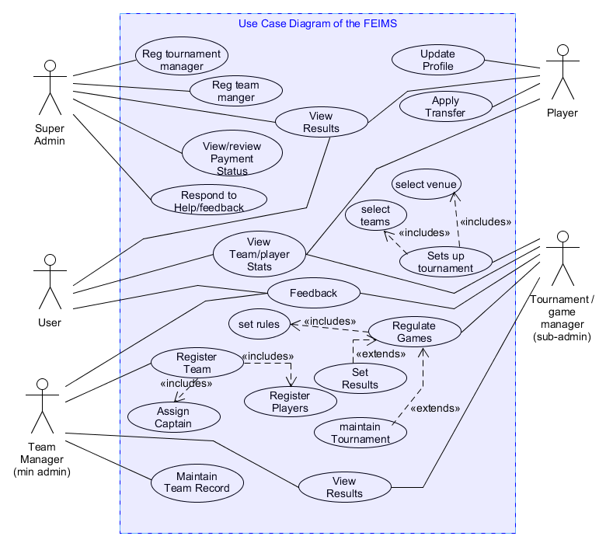

Figure 3 use case diagram of the FEIMS

**USE CASE ACTOR DESCRIPTION**

**Super Admin**

This is the overall system manager. From the term super to mean superior, is an actor who oversees the overall performance of the system as well as is able to oversee all operations that the system can perform.

**Tournament/Game Manager (Assistant admin)**

Enrolled by the admin. Oversees the success of the tournament. Mainly concerned with tournament activities as well as tournament administration work.

**Team Manager**

Enrolled by the Admin. In charge of team administration work including registration. Has limited functionalities constrained to team.

**User**

Front-end system user. One of the beneficiaries of the system. Is able to see all the events going on in the system. Is limited to viewingbut can edit his/her profile in case is registered.

**Player**

Belongs to a team. Is enrolled by the team manager. Can view stats, can edit profile, request for transfer, as well as give feedback. Takes part in the tournament by playing i.e. being part of the game.

**USE CASE DESCRIPTION**

Register Tournament manager

**Actor**: Admin

**Description**: To register someone to manage the tournament.

**Precondition**: A tournament manager must be an able competent person who is able to coordinate and ensure the success of the tournament.

**Flow of Event:**

1. Admin verifies registration of a tournament manager.
2. Admin activates an account for the tournament manager.
3. The system registers the tournament manager.
4. Use case ends.

**Post Condition:** Tournament Manager registered.

Register Team manager

**Actor**: Admin

**Description**: To register someone to manage the Team.

**Precondition**: A team manager must present the teams details including the players lists.

**Flow of Event:**

1. Admin verifies registration of a team manager.
2. Admin activates an account for the team manager.
3. The system registers the team manager.
4. Use case ends.

**Post Condition:** Team Manager registered.

View Results

**Actors**: Admin, Player, Tournament Manager, User

**Description**: To enable actors to view match results.

**Precondition**: Anyone is able to view the results from the home page.

**Flow of Event:**

1. The actor loads the website URL to the browser.
2. The home page loads with the results.
3. Use case ends.

**Post Condition:** Results Viewed.

Review payment status

**Actor**: Admin

**Description**: To review tournament registration fees or other fees.

**Precondition**: A payment reviews done on prompt by changing market prices or economic changes.

**Flow of Event:**

1. Admin finds need to verify tournament registration fee or other fees.
2. Admin changes the payment status.
3. The system updates the payment status.
4. The use case ends.

**Post Condition:** Payment reviewed.

Respond to help/feedback

**Actor**: Admin

**Description**: To respond to queries or reply users’ feedback.

**Precondition**: The admin has to receive a question or a comment that requires him/her to respond to.

**Flow of Event:**

1. Admin receives a notification that requires his/her attention.
2. Admin verifies that it requires a reply.
3. The admin replies to the query.
4. The system sends feedback to the recipient.
5. Use case ends

**Post Condition:** Help or feedback attended to.

Update Profile

**Actor**: player

**Description**: The player wants to update his or her profile.

**Precondition**: The player must be authorized that is the player should have been registered by the team manager.

**Flow of Event:**

1. The player wants to change his or her profile.
2. The player logs in.
3. If login is successful the player views and makes changes to the profile.
4. Else the player finding challenge to login attempts to change the password or contact the team manager through help to get assistance.
5. The system implements the changes.
6. Use case ends

**Post condition:** profile updated.

Apply Transfer

**Actor**: player

**Description**: To enable players to apply for transfers from their teams to other teams or clubs.

**Precondition**: The player should be authenticated and authorized by the team manager.

**Flow of Event:**

1. The player wants to apply for a transfer.
2. The player checks weather the transfer session is on.
3. The player applies for a transfer to the team he or she would like to go.
4. The system sends the transfer request.
5. The recipient team manager will reply to the sender’s team manager.
6. Use case ends.

**Post condition:** Transfer applied.

Set up tournament

**Actor**: Tournament Manager

**Description**: To enable the tournament manager to set up a tournament.

**Precondition**: The tournament manager must be authenticated by the super admin.

**Flow of Event:**

1. The tournament manager logs into the system.
2. Sets up the tournament (selects the teams, sets the rules, selects the venues)
3. The system activates the tournament.
4. Use case ends.

**Post condition:**  tournament set up.

Regulate games

**Actor**: Tournament Manager

**Description**: To ensure that the games are played within the required regulations.

**Precondition**: the tournament manager should be authenticated the tournament should be activated.

**Flow of Event:**

1. The tournament manager wants to regulate the games.
2. The tournament manager logs in.
3. Regulates the tournament(set results, set rules, performs maintenance action)
4. The system implements the changes.
5. Use case ends.

**Post Condition:** Games regulated.

Register Team

**Actor**: Team Manager

**Description**: To register team.

**Precondition**: The team manager must be authenticated, the team must include valid players (should provide documents supporting his/her skill, should also prove citizenship).

**Flow of Event:**

1. The team manager verifies that the team has viable players.
2. The team manager inserts the team’s details into the system (players, captain).
3. The system authenticates and registers the team.
4. Use case ends.

**Post Condition:**  Team Registered.

Maintain Team Records

**Actor**: Team Manager

**Description**: To ensure that the teams details are up to date.

**Precondition**: the team manager should be authorized and authenticated by the system admin and the system respectively.

**Flow of Event:**

1. The team manager ascertains that the team’s record needs to be updated.
2. The team manager logs in and updates the team’s record.
3. The system updates the record.
4. Use case ends.

**Post Condition:** The teams records maintained.

### 3.7.2 Class Diagram

Class diagrams offer a number of benefits for any organization. Use UML class diagrams to:

* Illustrate data models for information systems, no matter how simple or complex.
* Better, understand the general overview of the schematics of an application.
* Visually express any specific needs of a system and disseminate that information throughout the business.
* Create detailed charts that highlight any specific code needed to be programmed and implemented to the described structure.
* Provide an implementation-independent description of types used in a system that are later passed between its components.

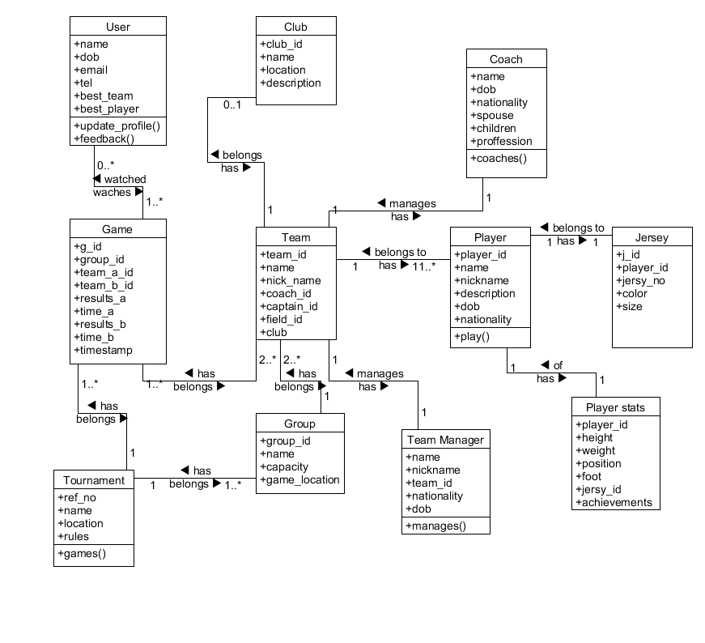

Figure 4 Class Diagram

### 3.7.3 Sequence Diagram

Advantages of sequence diagram:

* Easier to read.
* UML specification is more sequence diagram centric.
* Allows reverse engineering. One can be able to generate code for each sequence of activities from the sequence diagram.
* Excellent for documentation

Below I have illustrated a **sequence diagram for login scenarios** for all the actors of the system. Once an actor say an admin triggers the action to login the authentication interface (login interface) will be displayed prompting the actor to provide (insert) their user name and the password (pass). The system will then authenticate the details. If the actor authorized, the actor will be able to proceed to the next interface respectively of the actor’s user type (admin, team Manager, tournament Manager, and user). Besides, if the actor not authenticated the system will generate an error message then it will display the login interface once again.

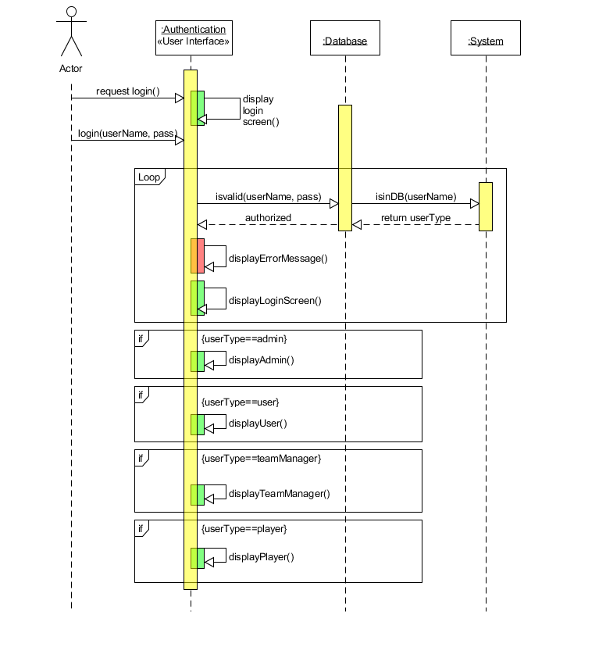

Figure 5 Sequence Diagram for Login Scenarios

## 3.8 Summary

From the basis, that a good and successful project stems from a well planned and executed project management methodology. In this section, I have put in what is required for the successful development of this project.

#### CHAPTER FOUR: ANALYSIS, INTERPRETATION AND DISCUSSION

## 4.1 Analysis and Discussion of Results

### 4.1.1 Introduction

Having clarified the concept in the previous chapter it would be in order if I clarified the concept in this chapter. The purpose of this chapter is to analyze and interpret the data collected in the previous chapter.

The questionnaire were distribute to students and sports management within Maseno University Kenya, some were emailed to club managers as well as team managers who reside at the campus periphery. An online questionnaire was scheduled as well to broaden the scope of responses.

The aim of this activity was to get peoples responses concerning the existing system as well the proposed system. The targeted respondents were appropriate since they have been in play for a couple of years and that looked an appropriate target to me.

### 4.1.2 Feedback from Questionnaire

#### 4.1.2.1 Qualitative analysis of the questionnaire

From the questionnaires that were issued out, there was so much to learn from including some of the respondent not being informed of any automation systems available. Most of the respondents pointed out that most of football tournament activities are just arranged manually and it was not a very efficient way to track down team performances as well as well as to save team records.

#### 4.1.2.2 Quantitative analysis of the questionnaire

From figure below, I can deduce that most of the respondents were unhappy with the current system. The 97% of the respondents turned negative about the current process of arranging tournaments. Precisely 60% responded as very unhappy, 20% were dissatisfied, 17% choosing the term tiresome while only 3% were okay with the current system. The 3% did not raise my concerns as the bigger picture had already captured in the 60% response.

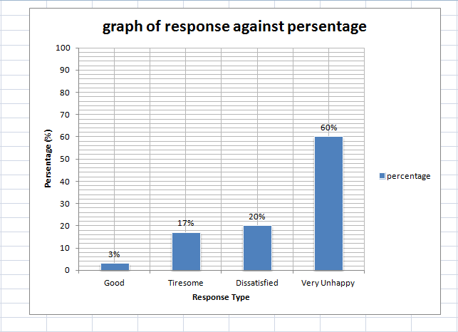

Figure 6 graph of responses against percentage